NAME : Chantelle Kamanga
REG NO : H250003M
COURSE : Object Oriented Programming
Practical Assignment 1
- Create an abstract class Account with protected fields accountNumber and balance, a constructor, a concrete deposit(double amount) method (rejecting non-positive amounts), a concrete getBalance() method, an abstract withdraw(double amount) method, and an abstract endOfMonth() hook method.

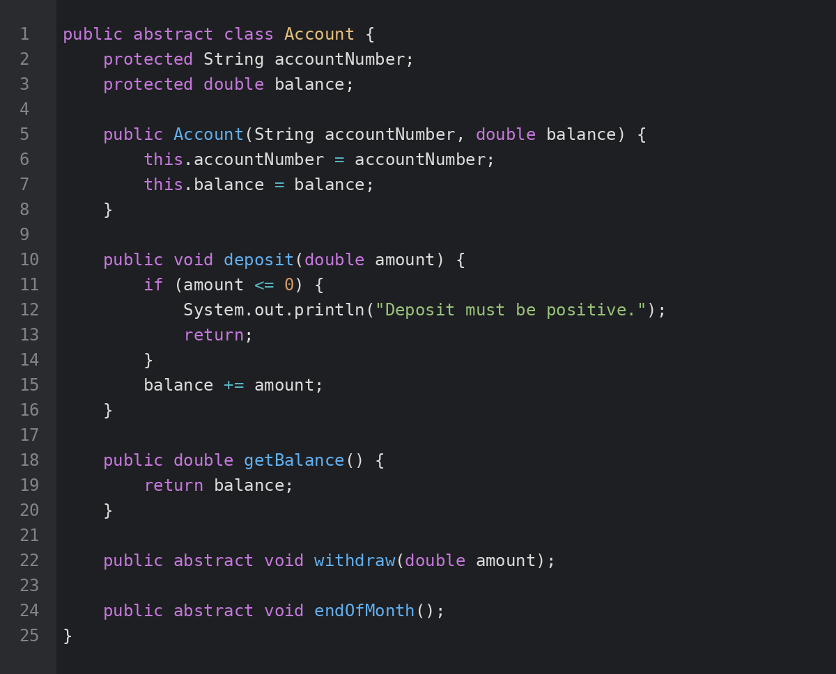

- Create SavingsAccount extends Account with a fixed minimumBalance. Override withdraw() to reject any withdrawal that would take the balance below the minimum, printing a clear message instead. Override endOfMonth() to apply a fixed interest rate to the balance.

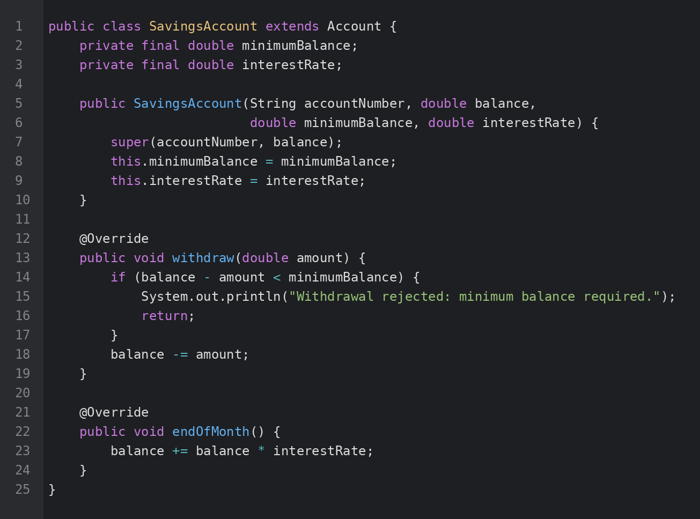

- Create CurrentAccount extends Account with an overdraftLimit. Override withdraw() to allow the balance to go negative, but not past the overdraft limit. Override endOfMonth() to deduct a small fixed monthly maintenance fee instead of paying interest.

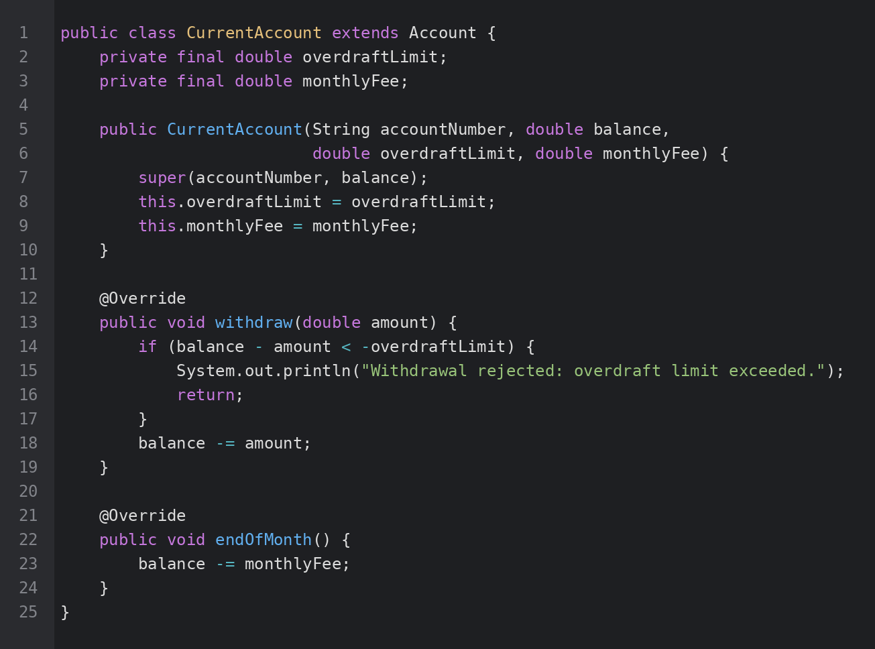

- In a BankDemo class, create a List<Account> (or Account[]) containing a mix of SavingsAccount and CurrentAccount objects. Loop through the list calling withdraw() and endOfMonth() through the Account reference only — do not cast to the subclass — and print the results, to demonstrate that the correct overridden version runs for each object.

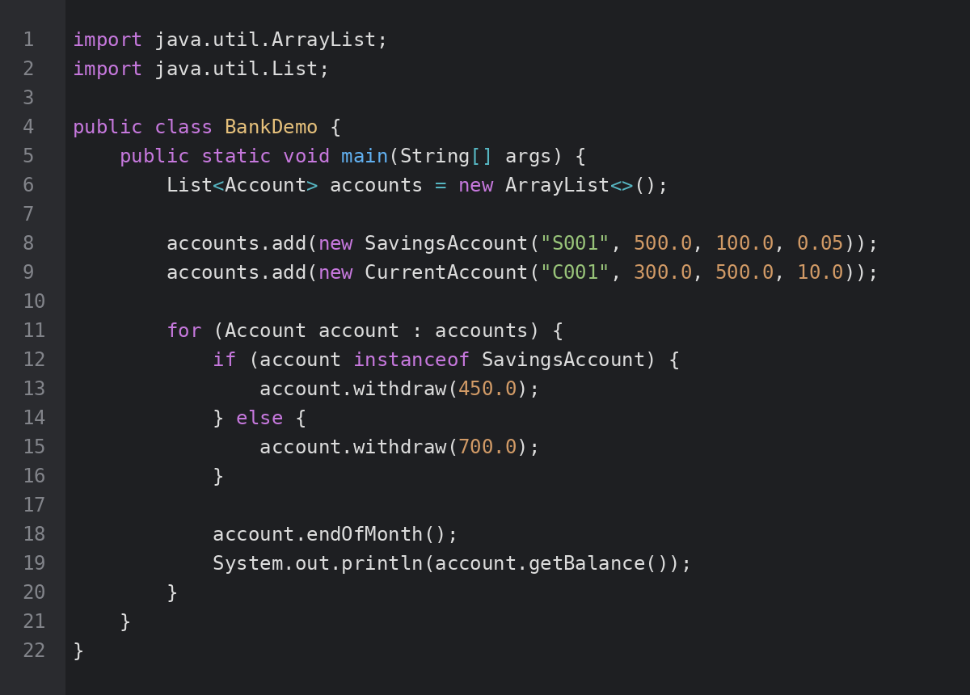

- Demonstrate at least one case where a SavingsAccount withdrawal is correctly rejected, and one where a CurrentAccount goes into overdraft within its limit.

